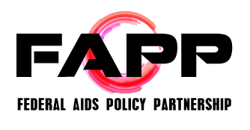

FAPP Meeting Agenda
Wednesday, March 4, 2015
10:00 AM to 3:30 PM
Drinker Biddle Reath LLP, located at 1500 K St NW
Call In Number: 1-605-475-5900; Passcode: 530-4686

Agenda

10:00 AM Roll Call

10:15 AM Funding/Appropriations Updates (AIDS Budget and Appropriations Coalition, ABAC)
- President’s Budget
- FY2016 next steps

11:00 AM Federal Partner Updates and Discussion – Dr. Eugene McCray (CDC)

- Topics for discussion to include:
  - FY2016 funding
  - High Impact Prevention next steps and opportunities
    - Improved promotion and access to PrEP
  - Affordable Care Act implementation
    - Essential Health Benefits (including HIV, STDs and viral hepatitis)
    - Testing and reimbursement
  - Special efforts to address gaps across the HIV Care Continuum and improve sexual health outcomes (across HIV, STD, and viral hepatitis), particularly for disproportionately impacted populations such as gay men/MSM of all races and ethnicities, people of color, young people, and transgender individuals

12:30 PM Lunch

1:15 PM Ending AIDS State and Local Plans
- New York – Dan Tiez, NYC Human Resources Administration; Kimberleigh Smith, Harlem United; Johanne Morne, NYSDOH AIDS Institute
- Washington – Dave Kern, Washington State Department of Health
- San Francisco – Stephanie Cohen, San Francisco Department of Health

3:00 PM Working Group Updates (continued)
- HIV Health Care Access Work Group
- Ryan White (Ryan White Work Group)
- Research/Global AIDS Policy Partnership (GAPP)
- HIV Prevention Action Coalition (HPAC)
- Structural Interventions

3:30 PM Adjourn

