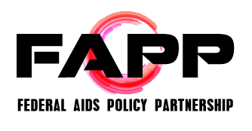

FAPP Meeting Agenda
Wednesday, April 15, 2015
10:00 AM to 3:30 PM
Drinker Biddle Reath LLP, located at 1500 K St NW
Call In Number: 1-605-475-5900; Passcode: 530-4686

Agenda

10:00 AM Roll Call

10:15 AM AIDS Watch 2015 Debrief
- Michael Kaplan and Ronald Johnson, AIDS United

11:00 AM Structural Interventions Work Group Overview and Updates

12:00 PM Lunch

1:00 PM PrEP Science Updates and Key Implementation Issues for Consideration – Speakers: Kevin Fisher, AVAC; Jonathan Fuchs, San Francisco Department of Public Health; Dave Kern, Washington State Department of Health; Amy Killelea, NASTAD
- Topics for discussion include:
  - Improving promotion and access to PrEP w/ a focus on disproportionately impacted populations such as gay men/MSM of color, women, young people, and transgender individuals
  - Addressing implementation gaps at the public health and community levels
  - Increasing provider knowledge
  - Increasing federal agency prioritization
  - Improving messaging around condomless sex and the implications for STD prevention
  - Addressing cost and financing gaps

2:30 PM AIDS Budget and Appropriations Work Group

2:45 PM Working Group Updates (continued)
- HIV Prevention Action Coalition (HPAC)
- Research/Global AIDS Policy Partnership (GAPP)
- HIV Health Care Access Work Group
- Ryan White (Ryan White Work Group)

3:30 PM Adjourn

